 **Fundamentals of programming lab manual 6**

**Name: Muhammad Amad Naeem**

**Section: ME-15 B**

**CMS ID: 467469**

**Teacher: Sir Affan**

**Task 1:**

**#include<iostream>**

**using namespace std;**

**int main(){**

**int num1=0,num2=1,sum=0,n;**

**cout<<"enter the total number of terms required(atleast 2): ";**

**cin>>n;**

**if(n>=3){**

**cout<<num1<<","<<num2;**

**for(int i=1;i<=n-2;i++){**

**for(int j=n;j<=n;j++){**

**sum=num1+num2;**

**num1=num2;**

**num2=sum;**

**cout<<","<<sum;**

**}**

**}**

**}**

**else{**

**cout<<num1<<","<<num2;**

**}**

**return 0;**

**}**

**Output:**

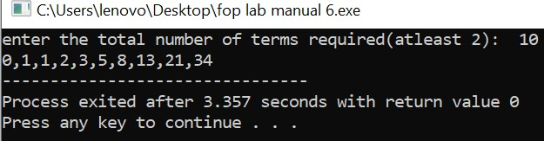

**Task 2:**

**#include<iostream>**

**using namespace std;**

**int main(){**

**int x;**

**cout<<"Enter the number of rows of the floyds triangle: ";**

**cin>>x;**

**int c=1;**

**for( int i=1; i<=x;i++){**

**for(int k=1; k<=i;k++){**

**cout<<c<<" " ;**

**c++;**

**}**

**cout<<endl;**

**}**

**}**

**Output:**

